 |  | Training Center News
Kiera Hill, TCC  Mary Mast, Training Site Coordinator and Training Faculty  970-381-5395  myeducationalresources@msn.com  Website: www.MyEducationalResouces.com  Instructor Network:  www. AHAinstructornetwork.com  eLearning Website for HeartCode Programs:  eLearning.heart.org |  | 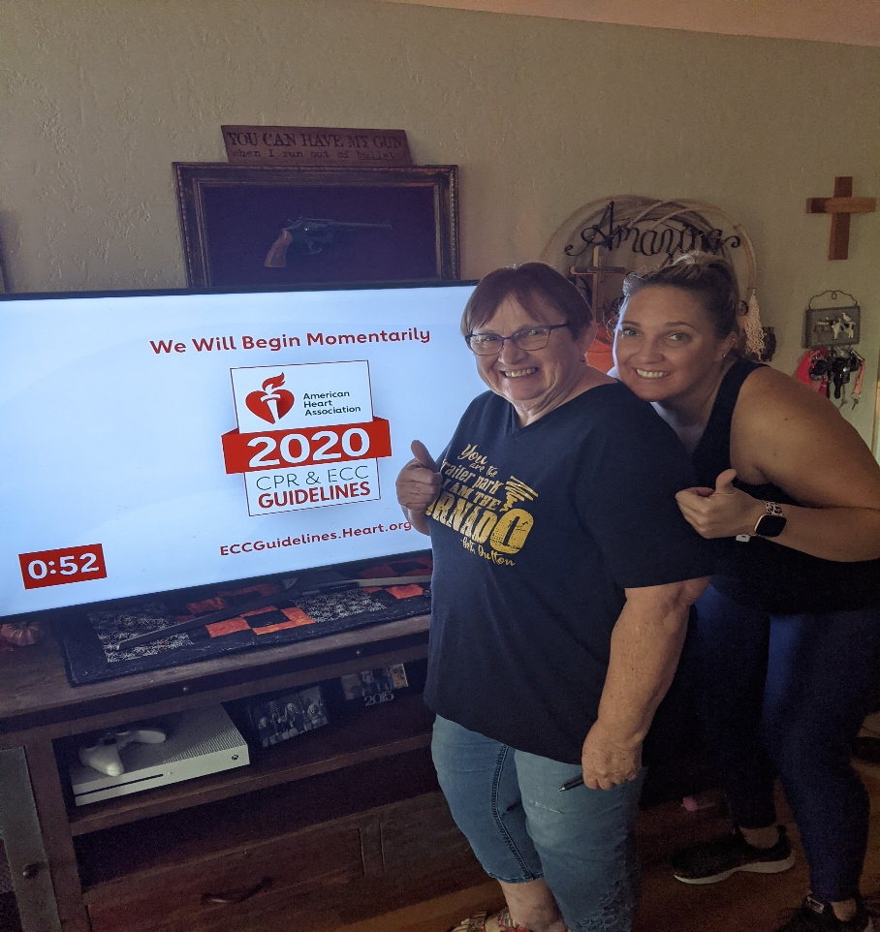
Office Hours  Monday-Friday  0800 to 1300 |  | Is it Fall yet?  Many of you have been experiencing the unprecedented temperatures that summer has brought upon us. We have both decided that we will not complain when winter comes this year.  Want to update you on a couple of things as we go into the last part of the year.  - Card fees will change October 15th. Heartsaver eCards will remain the same with an increase in BLS to $10.00 and ACLS/PALS to $15.00.  - Please remember that we have 5 days from the time that rosters are received to issue the eCards to your students and send you the confirmation email. There are some days when we can do a quick turn around but other days, especially weekends that may not occur.  - Effective October 15, 2022, we will be returning any rosters that are not filled out correctly, signed and indicate method of payment to you to complete. These delays eCards getting to your students in a timely fashion and creates emails to us, wondering where their eCard are. Please make sure each student has their own email address and we must be able to read the names. We have a fillable roster on our website that you can fill in, save as and send to us in an email attachment.  - For those ALS rosters, we must have the pre-assessment score as well as the final written score on the roster. This is a requirement per AHA and helps you guide your course to meet the needs of those students weak in some areas.  - If you have changed your email address, make sure we know and that you go into your profile on the instructor network and change it there too.  - We are contacting training sites who have coordinators and instructors who teach a lot of classes to identify if they want to issue their own eCards after classes are completed. We will slowly move to that process so please let us know if you are interested.  - We will require an email with the roster attached, requesting x number of eCards to be placed in the coordinator for that agency or individual instructor’s account. The agency or instructor will be invoiced via square and once payment is received; those eCards will be placed in their account for issuance. There will be no eCards assigned without documentation and payment. If you are interested in more information, please email us.  - We encourage you to keep a credit card on file through our user, Square to keep you from having to put the entire cc information on the roster. We can send you a form to complete so your cc information remains on a secure cc server. In this day and age, we want to add whatever we can to secure your information.  - Instructor Renewals are your responsibility and now that Covid and the guidelines that AHA gave us to help in the interim have expired, a reminder that you must submit the proper renewal form, course monitoring form completed by a Training Faculty member and the fee $35.00 prior to your expiration. Please consult the PAM for guidelines on number of classes required to renew.  - These renewal forms will also be returned to you if signatures and other documentation is received. Your quality scores from student’s evaluations are noted for each renewal and it is your responsibility to keep them current.  - Your instructor card will be issued as an eCard so you will get a message to claim from ecards@heart.org. Please remember that you must claim that eCard to continue to teach and send us a copy for the files indicating you have claimed it. Us issuing it does not complete the process, you must claim.  - Forms for renewal are on the instructor network, our website and we will be happy to send you a copy if needed.  - Instructor Renewals are sometimes difficult to schedule around your training faculty member so we are putting together 2023 Instructor Renewal Courses which will be conducted at different training sites in Wyoming and Colorado to update and renew your instructor cards. We are in the process of writing the guidelines and contacting TF to help us in various areas. If interested, let us know.  - Please review the difference between Heartsaver and Heartsaver Total courses to make sure you are providing the proper training for your agencies that need to be OSHA compliant. This is listed on page 3 and 27 of your Heartsaver Instructor Manual.  - Instructor training is so important, and we get numerous requests each week for those classes from all over the state. We will be conducting Instructor Training Faculty Courses soon so you can help us train these interested individuals and act as a resource for us in all the disciplines. You must be a Training Faculty member in the discipline that you want to teach. Please let us know if you are willing to host or participate in this project.  - Forms are being updated and available on our website. This is a fillable form so remember to save as then you can send via email.  - If you need to get ahold of us, please use the email address MyEducationalResources@msn.com for a quicker response.  - New options available for Heartsaver First Aid CPR AED Online  - The two Heartsaver First Aid CPR AED Online course paths are now available as two separate products for purchase.  - This eLearning course offers the convenience of digital learning for students who are required to take CPR and first aid training to meet job requirements.  - Please note: There have been no changes to the course content. The two separate course paths are the same course paths included in the original Heartsaver First Aid CPR AED Online product 20-1403. The two course paths are now provided separately for added convenience.  - What is the difference?  - Heartsaver Total – Heartsaver First Aid CPR AED (20-1440): This course path is designed to meet regulatory and OSHA requirements. Students are required to take the majority of topics. If all requirements are met, this course path results in a course completion card.  - Heartsaver Basic – Heartsaver First Aid CPR AED (20-1456; previously Heartsaver): This course path offers students the flexibility to choose more optional topics. This course path does NOT meet regulatory and/or OSHA requirements. If all requirements are met, this course path results in a course completion card.  - Following completion of the online portion, students must complete a hands-on skills session (sold separately by an AHA Training Center) with an AHA BLS or Heartsaver Instructor. See which topics are included in each course path in the Heartsaver course grid.

